Lymphatic System – Notes

- Fluid is forced from the bloodstream in the capillaries into the tissues due to high pressure.

The lymphatic system collects fluid in order to:
- Return it to the blood stream.
- Filter out disease-causing microorganisms.

The lymphatic system consists of:
- A network of lymph capillaries joined to longer lymph vessels.
- Lymph nodes located along the length of longer lymph vessels.

Components of the lymphatic system:
- Lymph.
- Lymphatic vessel:
– Lymphatic capillaries.
- Lymphatic vessels.
- Lymphatic trunks.
- Lymphatic ducts.
- Lymphatic organs:
- Thymus.
- Lymph nodes.
- Spleen.
- Tonsils.
- Lymphatic cells.

- The lymph ducts are the structures that drain back into the heart.
- The lymphatic cells consist of lymphocytes. They live inside the lymph nodes and help to destroy pathogens.

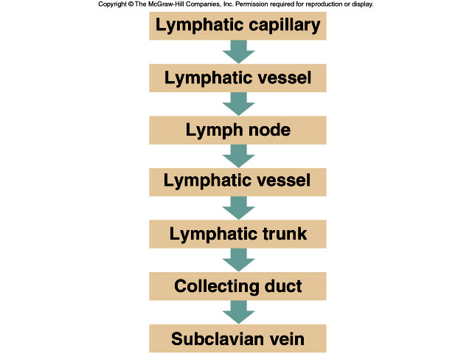

- Lymph: Tissue fluid (interstitial fluid) that enters the lymphatic vessels.
- Lymph is similar to plasma.
- Contains large proteins and disease-causing microorganisms.

Lymphatic capillaries:

Features of the structure of lymphatic capillaries:
- Blind end.
- Single layer of overlapping endothelial cells.
- More permeable than that of blood capillary.
- The network joins to form 2 large lymphatic ducts that empty lymph into the Subclavian veins.

Lymph nodes:

- Also called lymph glands.
- Occur at intervals along lymphatic vessels.
- Most numerous in the neck, armpits, groin and around the alimentary canal (digestive tract).
- Capsule of connective tissue forms a network.
- Contains masses of lymphoid tissue – cells known as lymphocytes, macrophages and plasma cells.

- Lymph vessels rely on skeletal muscle movement to transport lymph back into the circulatory system.
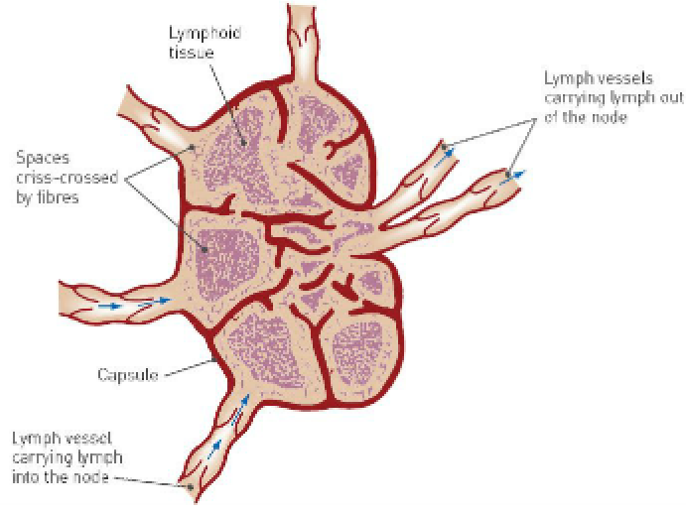
Role of the lymphatic system in defence against disease:

- Lymph entering nodes contains cell debris, foreign particles and microorganisms.
- Some can cause disease.
- Larger particles are trapped in lymphoid tissue.
- Macrophages consume these by phagocytosis.
- During infection, the numbers of lymphocytes increase, and the lymph nodes become sore and swollen.
- Infection in the finger may cause painful swelling in the armpits.
